1. Assignment 1
2. Select designations

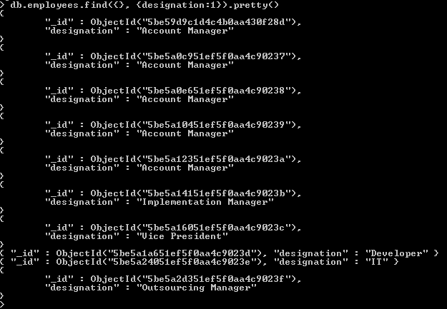

1. Where salary is greater than 7000

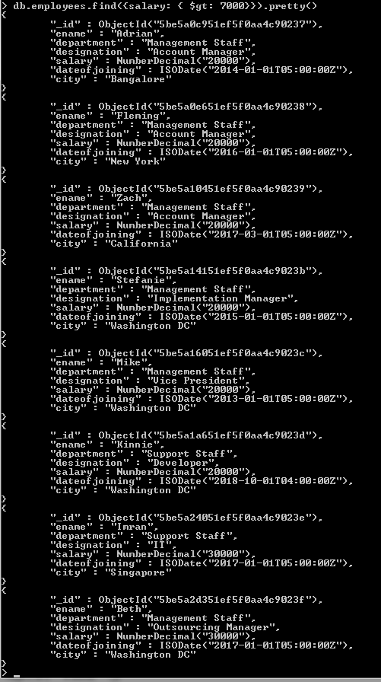

1. Sort by dateofjoining

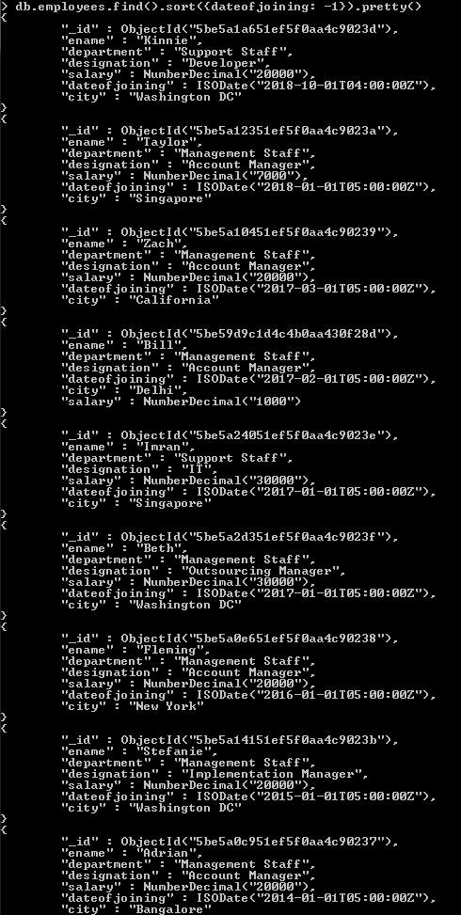

1. Sort by salary in ascending order

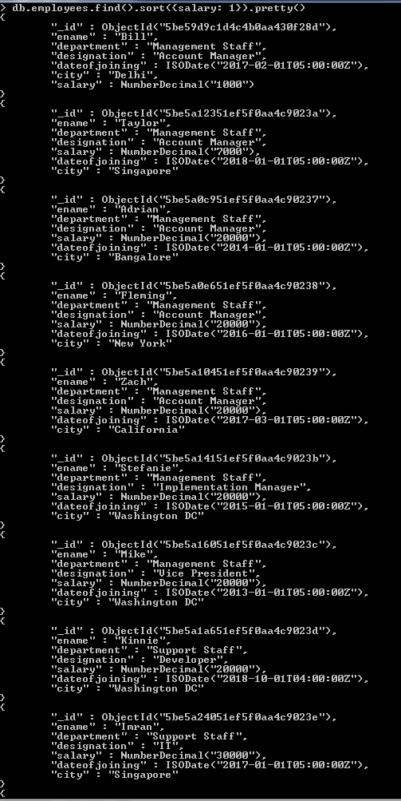

1. Where salary between 5000 and 40000

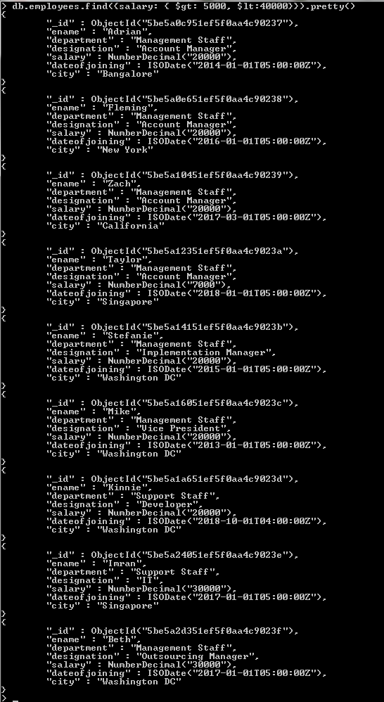

1. Where designation does not = “Developer”

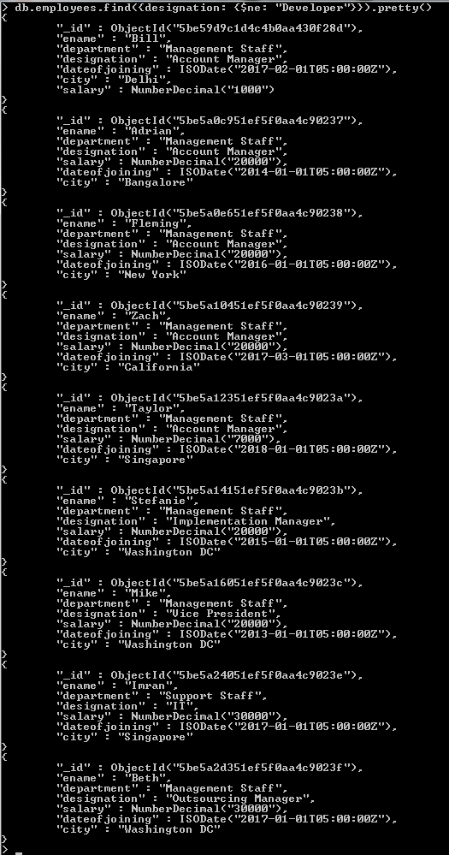

1. Sort by city descending

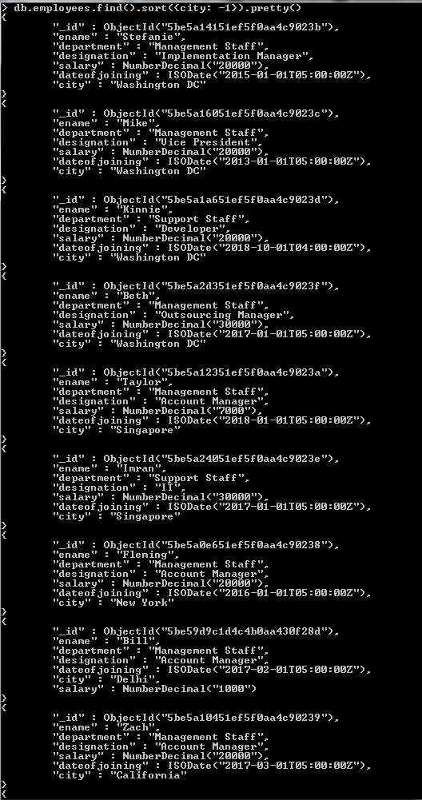

1. Where city starts with “Singapore” and salary is greater than 8000

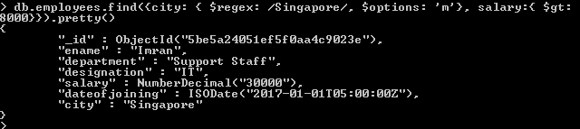

1. Drop employees collection

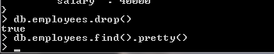

1. Assignment 2
2. Create app and establish connection to MongoDB

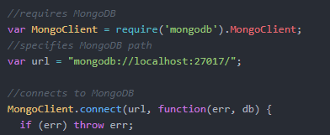

1. Add 5 more documents to the employees collection using insertmany()

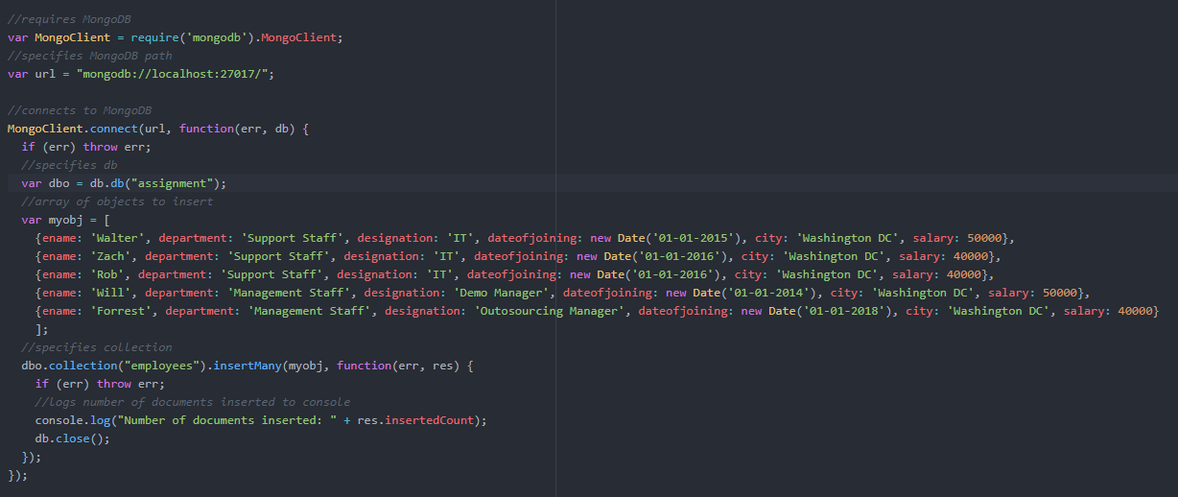

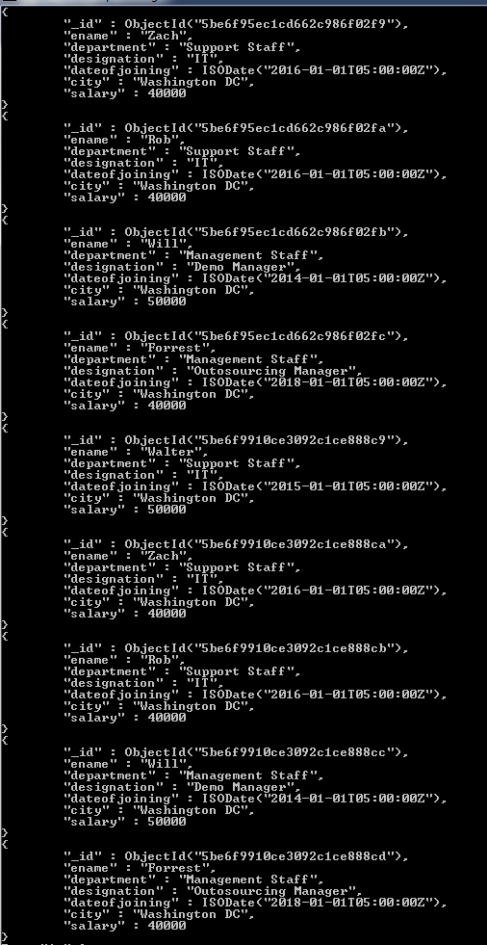

1. Delete documents where designation = ‘Developer’

